**Instance variable Usage**

1. Write a program to create the instance variable for the object using setattr method and access the attribute in parent class and child class after instatiation process is done.

class **parent**:

def **display1**(*self*):

print(*"parent"*,*self*.a)

class **child**(parent):

def **display**(*self*):

print(*"child"*,*self*.a)

ob=child()

setattr(ob,*'a'*,12)

ob.display1()

ob.display()

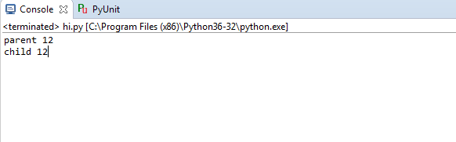

1. Write a program to create the instance variable for the object in parent class and use it in child class after instatiation process is done.

class **parent**:

def **display1**(*self*):

ob.v=122

print(*"parent"*,*self*.a,*self*.v)

class **child**(parent):

def **display**(*self*):

ob.v1=1222

print(*"child a="*,*self*.a,*'b='*,*self*.v,*'c='*,*self*.v1)

ob=child()

setattr(ob,*'a'*,12)

ob.display1()

ob.display()

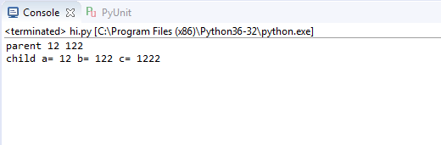

1. Write a program to create the instance variable for the object in child class and use it in parent class after instatiation process is done.

class parent:

def display1(self):

ob.v=122

print("parent",self.a,self.v,self.v1)

class child(parent):

def display(self):

ob.v1=1222

self.display1()

print("child a=",self.a,'b=',self.v,'c=',self.v1)

ob=child()

setattr(ob,'a',12)

ob.display()

